Supplementary material

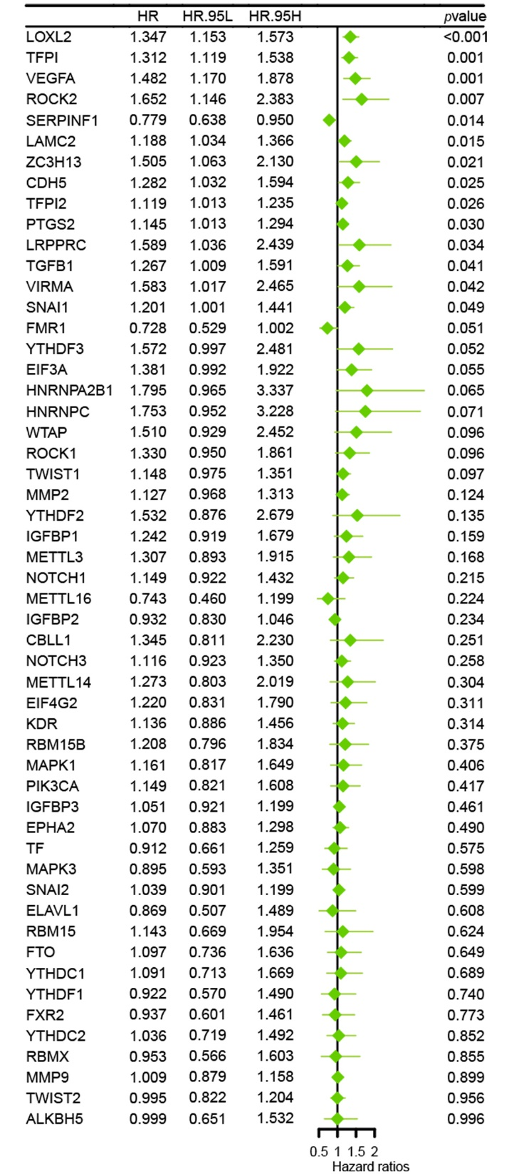
Supplementary Fig. 1. Forest plot of univariate Cox regression analysis of mVM genes.

Supplementary Fig. 2. The biological behaviours of the three clusters. (A–C) GSEA enrichment of KEGG pathway in clustering groups C1 and C2, C1 and C3, and C2 and C3, respectively.

Supplementary Fig. 3. Kaplan-Meier curves of the prognostic genes.

Supplementary Fig. 4. Prognostic value of mVMscore. (A,B) Kaplan-Meier curves of the mVMscore in the training set (A) and testing set (B). (C,D) Time-dependent ROC curve of the mVMscore prognostic signature for 1-, 3- and 5-year OS of CC patients in the training set (C) and testing set (D). (E,F) ROC curve analysis of the mVMscore and clinicopathological parameters for 1- (E), 3- (F) year OS of CC patients.

